Creating **bootstrap hyperlink dropdown**   
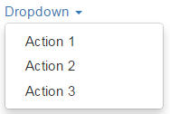  
  
**Here is the HTML required**

<div class="dropdown">

    <a data-toggle="dropdown" class="dropdown-toggle">

        Dropdown

        <span class="caret"></span>

    </a>

    <ul class="dropdown-menu">

        <li><a href="#">Action 1</a></li>

        <li><a href="#">Action 2</a></li>

        <li><a href="#">Action 3</a></li>

    </ul>

</div>

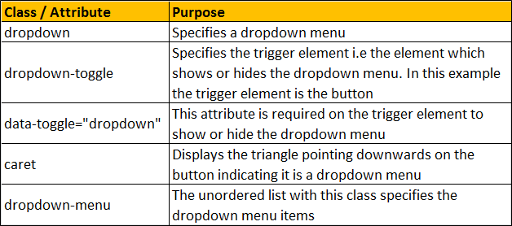  
  
**Creating bootstrap button dropdown**   
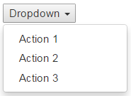  
  
To create a dropdown with a button as the trigger element, replace the anchor element with a button element as shown below.

<div class="dropdown">

    <button data-toggle="dropdown" class="dropdown-toggle">

        Dropdown

        <span class="caret"></span>

    </button>

    <ul class="dropdown-menu">

        <li><a href="#">Action 1</a></li>

        <li><a href="#">Action 2</a></li>

        <li><a href="#">Action 3</a></li>

    </ul>

</div>

Applying bootstrap button classes (btn & btn-primary) on the button element will style the dropdown button as shown below.   
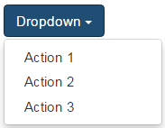  
  
**Dropdown menu header**   
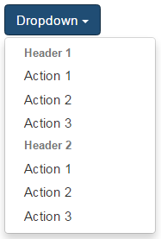  
  
To add a header to the dropdown menu, use dropdown-header class on an <li> element

<div class="dropdown">

    <button data-toggle="dropdown" class="btn btn-primary dropdown-toggle">

        Dropdown

        <span class="caret"></span>

    </button>

    <ul class="dropdown-menu">

        <li class="dropdown-header"><strong>Header 1</strong></li>

        <li><a href="#">Action 1</a></li>

        <li><a href="#">Action 2</a></li>

        <li><a href="#">Action 3</a></li>

        <li class="dropdown-header"><strong>Header 2</strong></li>

        <li><a href="#">Action 1</a></li>

        <li><a href="#">Action 2</a></li>

        <li><a href="#">Action 3</a></li>

    </ul>

</div>

**Dropdown menu divider**   
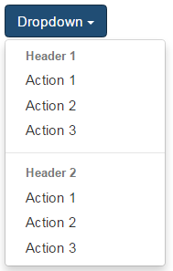  
  
To add a divider between the dropdown menu items, use divider class on an <li> element

<div class="dropdown">

    <button data-toggle="dropdown" class="btn btn-primary dropdown-toggle">

        Dropdown

        <span class="caret"></span>

    </button>

    <ul class="dropdown-menu">

        <li class="dropdown-header"><strong>Header 1</strong></li>

        <li><a href="#">Action 1</a></li>

        <li><a href="#">Action 2</a></li>

        <li><a href="#">Action 3</a></li>

        <li class="divider"></li>

        <li class="dropdown-header"><strong>Header 2</strong></li>

        <li><a href="#">Action 1</a></li>

        <li><a href="#">Action 2</a></li>

        <li><a href="#">Action 3</a></li>

    </ul>

</div>

**Disabled dropdown menu item**   
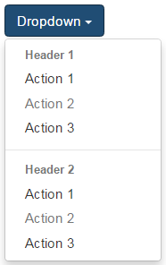  
  
To disable a menu item, use the disabled class

<div class="dropdown">

    <button data-toggle="dropdown" class="btn btn-primary dropdown-toggle">

        Dropdown

        <span class="caret"></span>

    </button>

    <ul class="dropdown-menu">

        <li class="dropdown-header"><strong>Header 1</strong></li>

        <li><a href="#">Action 1</a></li>

        <li class="disabled"><a href="#">Action 2</a></li>

        <li><a href="#">Action 3</a></li>

        <li class="divider"></li>

        <li class="dropdown-header"><strong>Header 2</strong></li>

        <li><a href="#">Action 1</a></li>

        <li class="disabled"><a href="#">Action 2</a></li>

        <li><a href="#">Action 3</a></li>

    </ul>

</div>

If you want the dropdown menus to expand upwards, nest the dropdown markup in a <div> element with class dropup as shown below.   
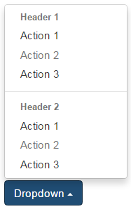  
  
Here is the HTML

<div class="dropup">

    <div class="dropdown">

        <button data-toggle="dropdown" class="btn btn-primary dropdown-toggle">

            Dropdown

            <span class="caret"></span>

        </button>

        <ul class="dropdown-menu">

            <li class="dropdown-header"><strong>Header 1</strong></li>

            <li><a href="#">Action 1</a></li>

            <li class="disabled"><a href="#">Action 2</a></li>

            <li><a href="#">Action 3</a></li>

            <li class="divider"></li>

            <li class="dropdown-header"><strong>Header 2</strong></li>

            <li><a href="#">Action 1</a></li>

            <li class="disabled"><a href="#">Action 2</a></li>

            <li><a href="#">Action 3</a></li>

        </ul>

    </div>

</div>